**Supervised Learning to Predicting Crop Yields in Pakistan Based on Climatic Changes**

**Abstract:** Agriculture is the backbone of Pakistan's economy in which most of the people are depending on agriculture resources. Agriculture productivity depends on weather conditions and Pakistan is a gifted country with more crops and weathers. Each crop has its unique ability to grow in different weather conditions. In Agriculture cultivation of food is a major problem due to various climatic changes the food productivity around the nation got affected year by year. Due to these serious issues, the nation got affected by the net productivity of major crops like cotton, wheat, rice, sugarcane, etc. It is necessary to save the food resources for future generations. By analyzing all these factors, there is no proper solution and technologies for the farmers to predict crop productivity based on climatic changes. This research will help farmers to predict crop production and made them cultivate more crops according to weather conditions. For this purpose, we will use supervised machine learning technique Random Forest Regression for predicting crop productivity in Pakistan based on climatic conditions.

**Introduction:**  Agriculture is a vital sector of Pakistan's economy as it contributes 18.9 percent to GDP and absorbs 42.3 percent of the labor force, according to government estimates. The Agriculture field openly supports 45% of the country's population, contributes a large share of overseas exchange earnings, and employs partly the labor force. The main farming crops are sugarcane, rice, wheat, cotton, maize, etc.

Due to some factors like climate change, lack of modern technology, a decrease in water level, the use of pesticides excessively, etc the level of agriculture in Pakistan is decreasing day by day.

Predicting crop yields based on climate change is an important agricultural problem. In Pakistan, agriculture yield production depends upon the weather conditions. Therefore, timely predict the productivity of the crop will help farmers to the maximum crop yields.

**Problem Statement:**

The crop yields are affected by several climate factors like humidity, wind speed, temperature, moisture, irrigation, etc. And due to constant change in climate conditions everything is messed. In Pakistan farmers still follow the old method which they adopted from their forefathers. But the problem is that at the earliest time the climate was very comfortable for crops everything occurred on schedule. But currently, most of the things have been changed due to global warming and lots of other factors. To solve this problem farmers need a recommender system to predict which crop should sow so that they can get more benefits.

**Literature Review:**

In this paper [1] authors examine the effects of climate change on the major crops of Pakistan. In this research, they used statistical data based on climate change like temperature, rainfall, humidity, etc. The results of the study reveal that maximum temperature negative effect on major crops like wheat, rice, while the minimum temperature is a positive effect on all major crops in Pakistan.

In this paper [2] authors proposed research on the crop productions of Pakistan which affected by changes in weather. For this research, they used the past 2005 to 2014 secondary data on crop yields. This Research show that Rainfall and consistent increase in temperature can bring change in major crops like rice, crops, wheat, etc productions.

In this paper [3] authors focus on this research was to investigate how climate change was on effect majors crops like cotton and sugarcane yield in Punjab, Pakistan. This research reveals that climate change especially temperature is a major effect in this region.

**Research Objective:**

* To build a recommender system for farmers to predict which crop should sow.
* To determine the climate condition based on historical data.
* To implement a robust supervised technique for predicting crop yields.

**Significance of the Study:**

* The farmer could get to know which crop to be grown for a particular climate.
* The farmer could get to know the climatic condition based on historical data.
* Timely predict will help farmers to the maximum crop yields.

**System Architecture:**

The System Architecture of this research is as the following:

1. **Data Collection:** For this research, we will use the past two decades Pakistan crop yield data. The dataset will describe the agriculture crop cultivation and production in Pakistan and crop productivity based on climatic conditions will be predicted by considering fields like Crop, State, District, Crop year, Season, Area, Production, etc.
2. **Data Preprocessing:** Data exploration is the initiation of our research. Analyzing the entire dataset will help us to enhance the research. In dataset preprocessing, we will clean the data and confirm that data is ready for our research output.
3. **Split the Data:** Once we confirm that data is ready for our final output then we will split the data for the training and testing step.
4. **Building the Model:** For this Research, we will use the Random Forest Regression model. Random Forest one of the Machine Learning technique which used to solve the classification and regression problems. In this study, we will use the Random Forest Regression model which will help to predict crop productivity with respect to climate conditions.
5. **Result Evaluation:** After implementing our model we will test our data and calculate the productivity of crops based on climate change.

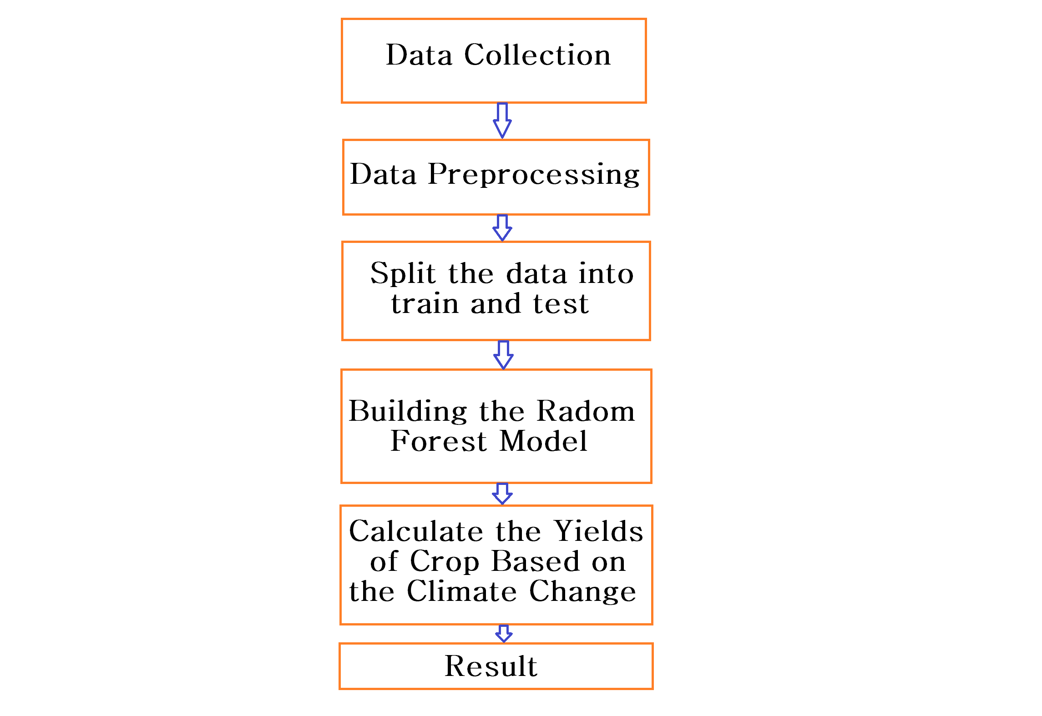**Figure 1:** System Architecture

**Research Plan:**

The timeline for the research plan in Japan is as the following:

|  |  |  |  |  |  |  |  |  |  |  |  |  |
| --- | --- | --- | --- | --- | --- | --- | --- | --- | --- | --- | --- | --- |
|  | **Sep**  **2021** | **Oct**  **2021** | **Nov**  **2021** | **Dec**  **2021** | **Jan**  **2022** | **Feb**  **2022** | **Mar**  **2022** | **Apr**  **2022** | **May**  **2022** | **Jun**  **2022** | **Jul**  **2022** | **Aug**  **2022** |
| **Arrival**  **University** | ⚫ |  |  |  |  |  |  |  |  |  |  |  |
| **Literature Review** |  | ⚫ | ⚫ | ⚫ |  |  |  |  |  |  |  |  |
| **Introduction** |  |  |  |  | ⚫ | ⚫ |  |  |  |  |  |  |
| **Data Collection** |  |  |  |  |  |  | ⚫ | ⚫ | ⚫ |  |  |  |
| **Methodology** |  |  |  |  |  |  |  |  |  | ⚫ | ⚫ | ⚫ |

**Table 1:** First Year Plan in Master Research

|  |  |  |  |  |  |  |  |  |  |  |  |  |
| --- | --- | --- | --- | --- | --- | --- | --- | --- | --- | --- | --- | --- |
|  | **Sep**  **2022** | **Oct**  **2022** | **Nov**  **2022** | **Dec**  **2022** | **Jan**  **2023** | **Feb**  **2023** | **Mar**  **2023** | **Apr**  **2023** | **May**  **2023** | **Jun**  **2023** | **Jul**  **2023** | **Aug**  **2023** |
| **Results Evaluation** | ⚫ | ⚫ |  |  |  |  |  |  |  |  |  |  |
| **Application Design** |  |  | ⚫ | ⚫ | ⚫ | ⚫ | ⚫ | ⚫ |  |  |  |  |
| **Thesis Report** |  |  |  |  |  |  |  |  | ⚫ | ⚫ | ⚫ | ⚫ |

**Table 2:** Second Year Plan in Master Research

**Reference:**

[1] Ali, S., Liu, Y., Ishaq, M., Shah, T., Abdullah, Ilyas, A., & Din, I. U. (2017). Climate Change and Its Impact on the Yield of Major Food Crops: Evidence from Pakistan. Foods (Basel, Switzerland), 6(6), 39. https://doi.org/10.3390/foods6060039.

[2] Magsi, Habibullah & Rashid, Muhammad Khalid & Khushk, Ghulam & Khatyan, Mohsin & Babar, Muhammad. (2018). Impact of Climate Change on Major Crops of Pakistan. SALU-Commerce & Economic Review. 4. 70-77.

[3] Akbar, H., Gheewala, S.H. (2020). Effect of climate change on cash crops yield in Pakistan. Arab J Geosci 13, 390. https://doi.org/10.1007/s12517-020-05333-7.

[4] Ehsan Najafi, Naresh Devineni, Reza M. Khanbilvardi, Felix Kogan. (2018). Understanding the Changes in Global Crop Yields Through Changes in Climate and Technology. Earth's Future. 10.1002/2017ef000690.

[5] Fathi, Maroi & Ezziyyani, Mostafa & el Mamoune, Soumaya. (2019). Data Mining for Predicting the Quality of Crops Yield Based on Climate Data Analytics: Methods and Protocols. 10.1007/978-3-030-11878-5_8.

[6] Gandhi, Niketa & Petkar, Owaiz & Armstrong, Leisa & Tripathy, Amiya. (2016). Rice crop yield prediction in India using support vector machines. 1-5. 10.1109/JCSSE.2016.7748856.

[7] Khosla, E., Dharavath, R. & Priya, R. (2020). Crop yield prediction using aggregated rainfall-based modular artificial neural networks and support vector regression. Environ Dev Sustain 22, 5687–5708. https://doi.org/10.1007/s10668-019-00445-x.